ASSIGNMENT 2

Soal 1

**SELECT** * **FROM** customers c;

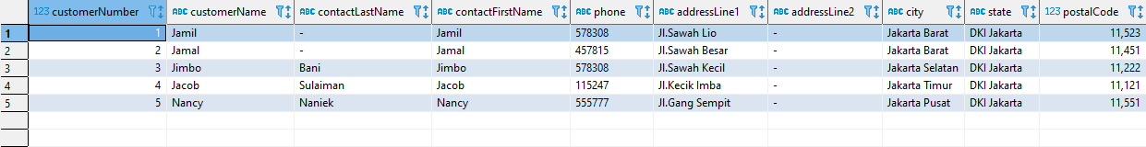

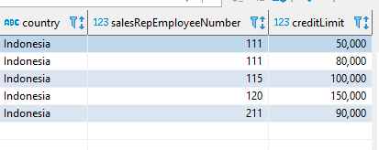

Soal 2

**SELECT** * **FROM** productlines;

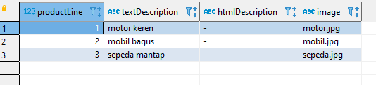

Soal 3

**SELECT** * **FROM** products;

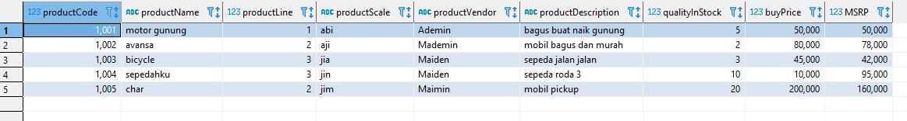

Soal 4

**SELECT** * **FROM** orders;

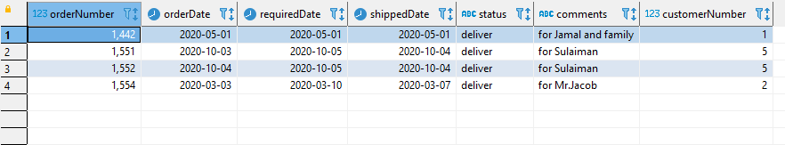

Soal 5

**SELECT** * **FROM** orderdetails;

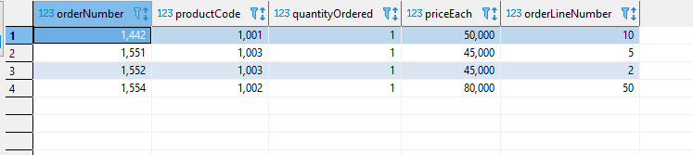

Soal 6

**SELECT** * **FROM** payments;

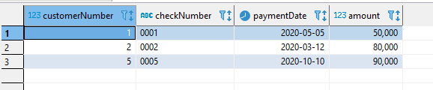

Soal 7

**SELECT** * **FROM** employees;

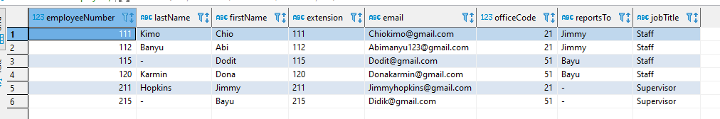

Soal 8

**SELECT** * **FROM** offices;

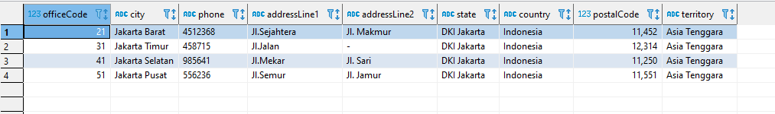

Modif 1

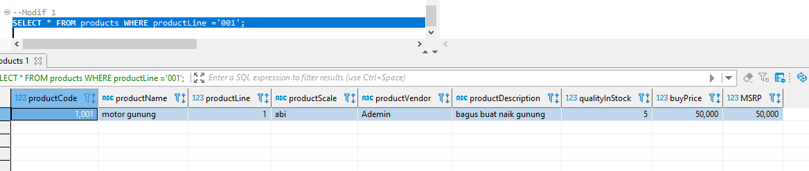

Modif 2

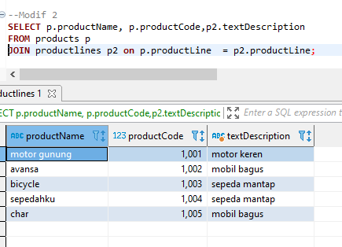

Modif 3

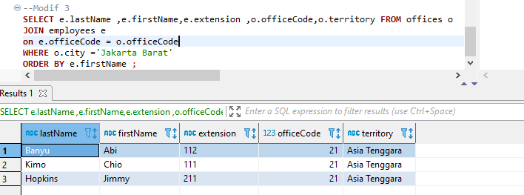

Modif 4

